EMERGENCY!
CAN WE FIND YOU?
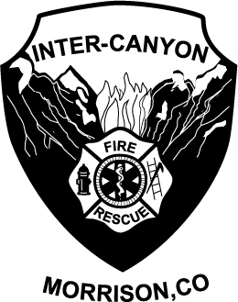

HOUSE NUMBER SIGNS ARE FOR SALE FROM
INTER-CANYON FIRE PROTECTION DISTRICT

Help local emergency service personnel find your home faster. This standard numbering program will make finding houses easier for everyone. The last thing you need to worry about during an emergency, when seconds may count, is if rescuers will be able to locate your home. Signs are made of rust free aluminum, measure 5”x 14” (4 digits) or 5”x 16” (5 digits) with a blue reflective background and white numbers. They are one sided and horizontally oriented and may be ordered by mailing the requested information below to Inter-Canyon Fire Protection District. Four digit signs are available for $22.00 and five digits for $25.00. When complete, you can pick up your sign at ICFPD Station 1 or for an additional $5.00 we will mail the sign to you. If you have any questions or would like to place an order please call 303-697-4413.
Thanks for helping us to help you!
Inter-Canyon Fire Fighters

Return this portion with your check made out to Inter-Canyon Fire Protection District., 7939 S. Turkey Creek Rd., Morrison, CO 80465 Attn: Administration

Name: ________________________________________________
Address: ______________________________________________
Telephone # (day/eve) ___________________________________

Number on Sign:

